**Lab Number: 06 Date: 2025/08/08**

# Title: Creating a LAN and testing the connectivity using Packet Tracer

# THEORY:

**a. LAN & its Architecture**

A Local Area Network (LAN) is a network that connects computers and devices within a limited geographical area, such as home, office, or a building. LAN’s are used to share resources like files, printers, and internet connections among multiple devices. Because LAN’s cover smaller areas, they usually have higher data transfer speeds and lower latency compared to larger networks like WAN’s (Wide Area Networks).

**Key Features:**

1. It is a private network, so an outside regulatory body never controls it.
2. LAN operates at a relatively higher speed compared to other WAN systems.
3. There are various kinds of media access control methods like token ring and Ethernet.
4. It connects computers in a single building, block or campus.

**LAN Architecture:**

LAN architecture defines the structure, components, and communication protocols of a LAN. It involves several key elements:

**Key Components:**

**Switches and Hubs:** Switches intelligently forward data to specific devices, while hub broadcast data to all devices.

**Ethernet Cables:** Commonly used cables include Cat5e, Cat6e, and fiber optics.

**Network Interface Cards (NICs):** NICs are hardware components that allow devices to connect to the Ethernet.

**Topologies**

The physical arrangement of devices in a LAN is called topology. Common topologies are:

1. Star topology

2. Ring topology, etc.

**Protocols**

LAN’s use protocols to ensure smooth communication. Some common protocols are: **Ethernet, Wi-Fi & TCP/IP**

**b. Components Used:**

**Hardware:** Switches (1), Ethernet cables, End devices (4)

**Software:** Cisco Packet Tracer

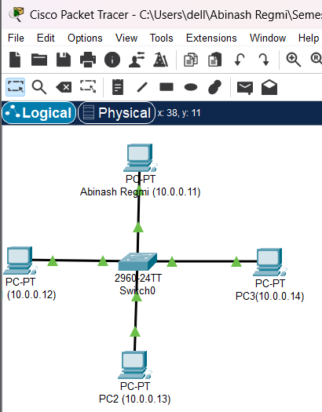**c. Network Diagram:**

Fig: Network Diagram of LAN

**Procedure**

Here is the procedure for creating the LAN network shown in the image using Cisco Packet Tracer:

**Step 1: Launch Cisco Packet Tracer**

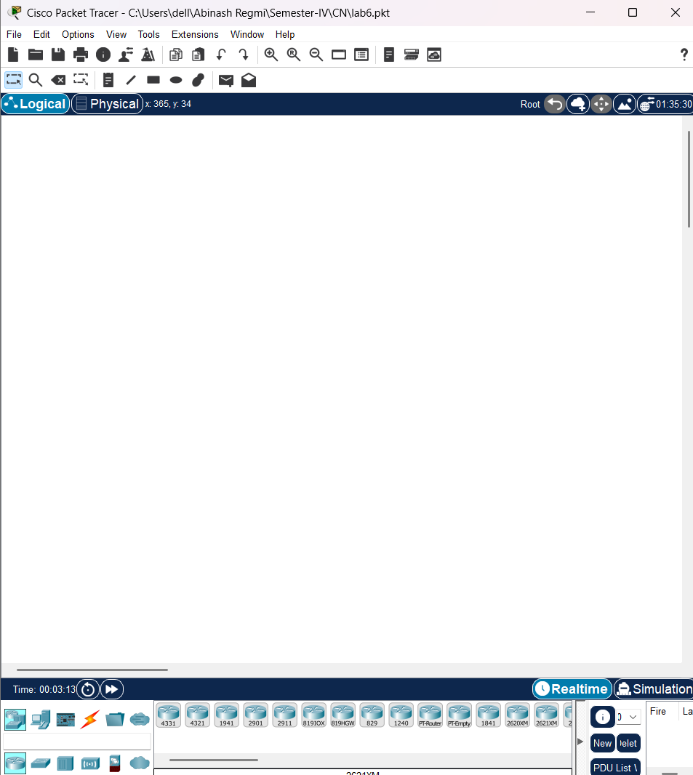

Fig: Workspace for network design

**Step 2: Add the network devices to the workspace**

2.1 From the Device-Type Selection box, choose the following devices and add them to the workspace:

2.2 One 2690-24TT Switch

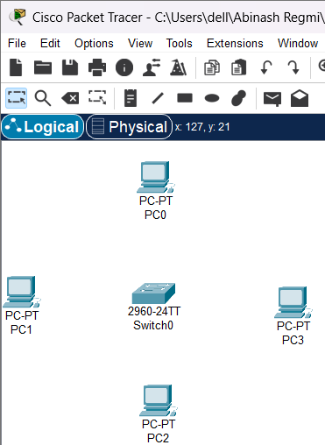2.3 Four PCs (labelled PC0, PC1, PC2, and PC3)

Fig: Switches and PCs for LAN creation

**Step 3: Connect the devices**

3.1 Use the copper straight-through cable to connect each PC to one of the available ports on the switch.

 3.2 Ensure that each connection is made properly.

Fig: Connection between Switch and PCs

**Step 4: Configure IP addresses**

4.1 Right-click on each PC and select “IP Configuration”.

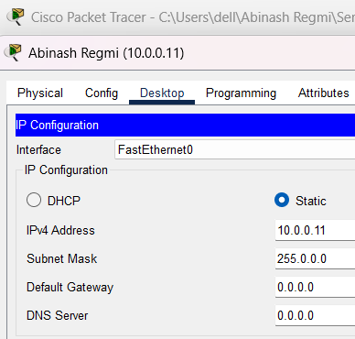 4.2 In the IP Configuration window, enter the IP address as (10.0.0.11 to 10.0.0.14), subnet mask, and default gateway for each PC.

Fig: IP configuration

**Step 5: Testing and Validation**

5.1 To test whether the network is working, you can ping other devices on the network from each PC.

5.2 To ping another device, open a command prompt on the PC and type “ping” <IP address of the other device>.”

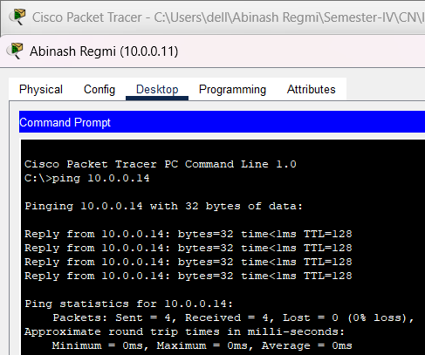5.3 If the ping is successful, you should see replies from the other device.

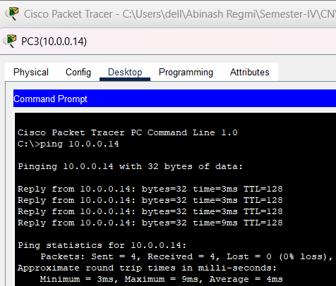fig: Connectivity test between network PC0(Abinash) and PC3

Fig: Connectivity test between PC3 and PC0(Abinash)

**Conclusion**

Creating a Local Area Network (LAN) in Cisco Packet Tracer provides a hands-on understanding of how devices within a network are interconnected and how they communicate with each other. Through this process, we can simulate the design and configuration of a LAN, including the placement and connection of key components such as routers, switches, and end devices (PC). It allows us to ensure network connectivity.